EL1001-LCA LAB
FINAL PROJECT (Report)


BATTARY LEVEL INDICATOR
Submitted by:

MATEEN AHMED 25I-6065
AARIZ WASEEM 25L-6104

Submitted to:
MUIZ MALIK

MAY 13, 2026
1. Objective

The objective of this project is to design and implement a Battery Level Indicator using LM741 operational amplifiers as comparators. The circuit is used to monitor battery voltage levels and indicate the battery condition through LEDs. Different LEDs glow when the battery voltage reaches specific threshold values.

2. Project Statement
Design and implement a Battery Level Indicator that checks battery levels and illuminates LEDs based on defined voltage thresholds derived from the roll numbers of both group members.
The last two digits of each roll number are used to determine four voltage levels in ascending order.
For our group, the obtained voltage levels are:
1V, 4V, 5V, and 6V
The system uses LM741 operational amplifiers configured as comparators to compare the battery voltage with reference voltages. When the battery voltage exceeds a threshold, the corresponding LED turns ON.

3. Theory
A comparator is an electronic circuit that compares two input voltages and provides a high or low output depending on which voltage is greater.
The LM741 operational amplifier is used as a comparator.
The comparator operation is:
If:
Vin > Vref
Output becomes HIGH and LED turns ON.
If:
Vin < Vref
Output remains LOW and LED stays OFF.
Reference voltages are generated using resistor voltage divider networks.
Where:
- Vref = Reference voltage
- Vcc = Supply voltage
4. Components Required
Active Components
- LM741 Operational Amplifier × 4
Passive Components
- Resistors
Output Devices
- Red LED × 1
- Yellow LED × 1
- Green LED × 1
- Blue/White LED × 1
Other Components
- Breadboard / PCB
- Connecting wires
- Dual power supply (+12V, -12V)
- Variable DC voltage source
6.Threshold Voltage Design
Comparator | Threshold Voltage
Comparator 1 | 1V
Comparator 2 | 4V
Comparator 3 | 5V
Comparator 4 | 6V

7. Observations
The circuit successfully indicated battery voltage levels.
Observed LED operation:
Input Voltage | LED Status

Below 1V | All OFF

1V – 4V | LED1 ON

4V – 5V | LED1, LED2 ON

5V – 6V | LED1, LED2, LED3 ON

Above 6V | All LEDs ON

8. SOFTWARE SIMULATION :
Circuit made on proteus.
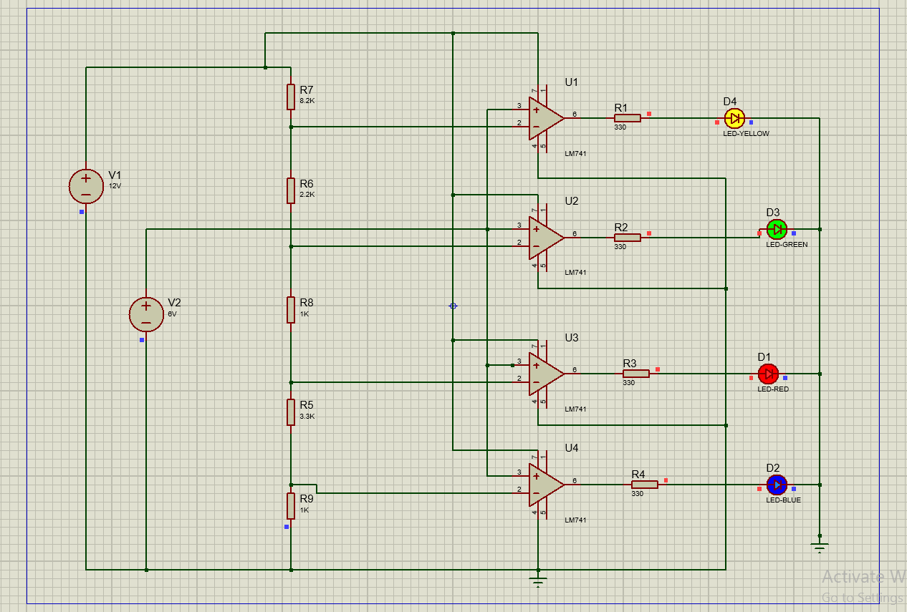

9. HARDWARE IMPLENTATION:
Circuit implemented on breadboard with dual supply.


14. Conclusion
The Battery Level Indicator using LM741 comparators was successfully designed and implemented.
The circuit accurately detected battery voltage levels and illuminated LEDs at predefined thresholds of 1V, 4V, 5V, and 6V.
This project demonstrated the practical use of operational amplifiers as comparators and enhanced understanding of voltage division and comparator-based monitoring systems.

